**JPMSys – Jewelry Process Management System Help Document**

**Login:**

* **Accessing the Application:** Enter your **username** and **password** to log in.

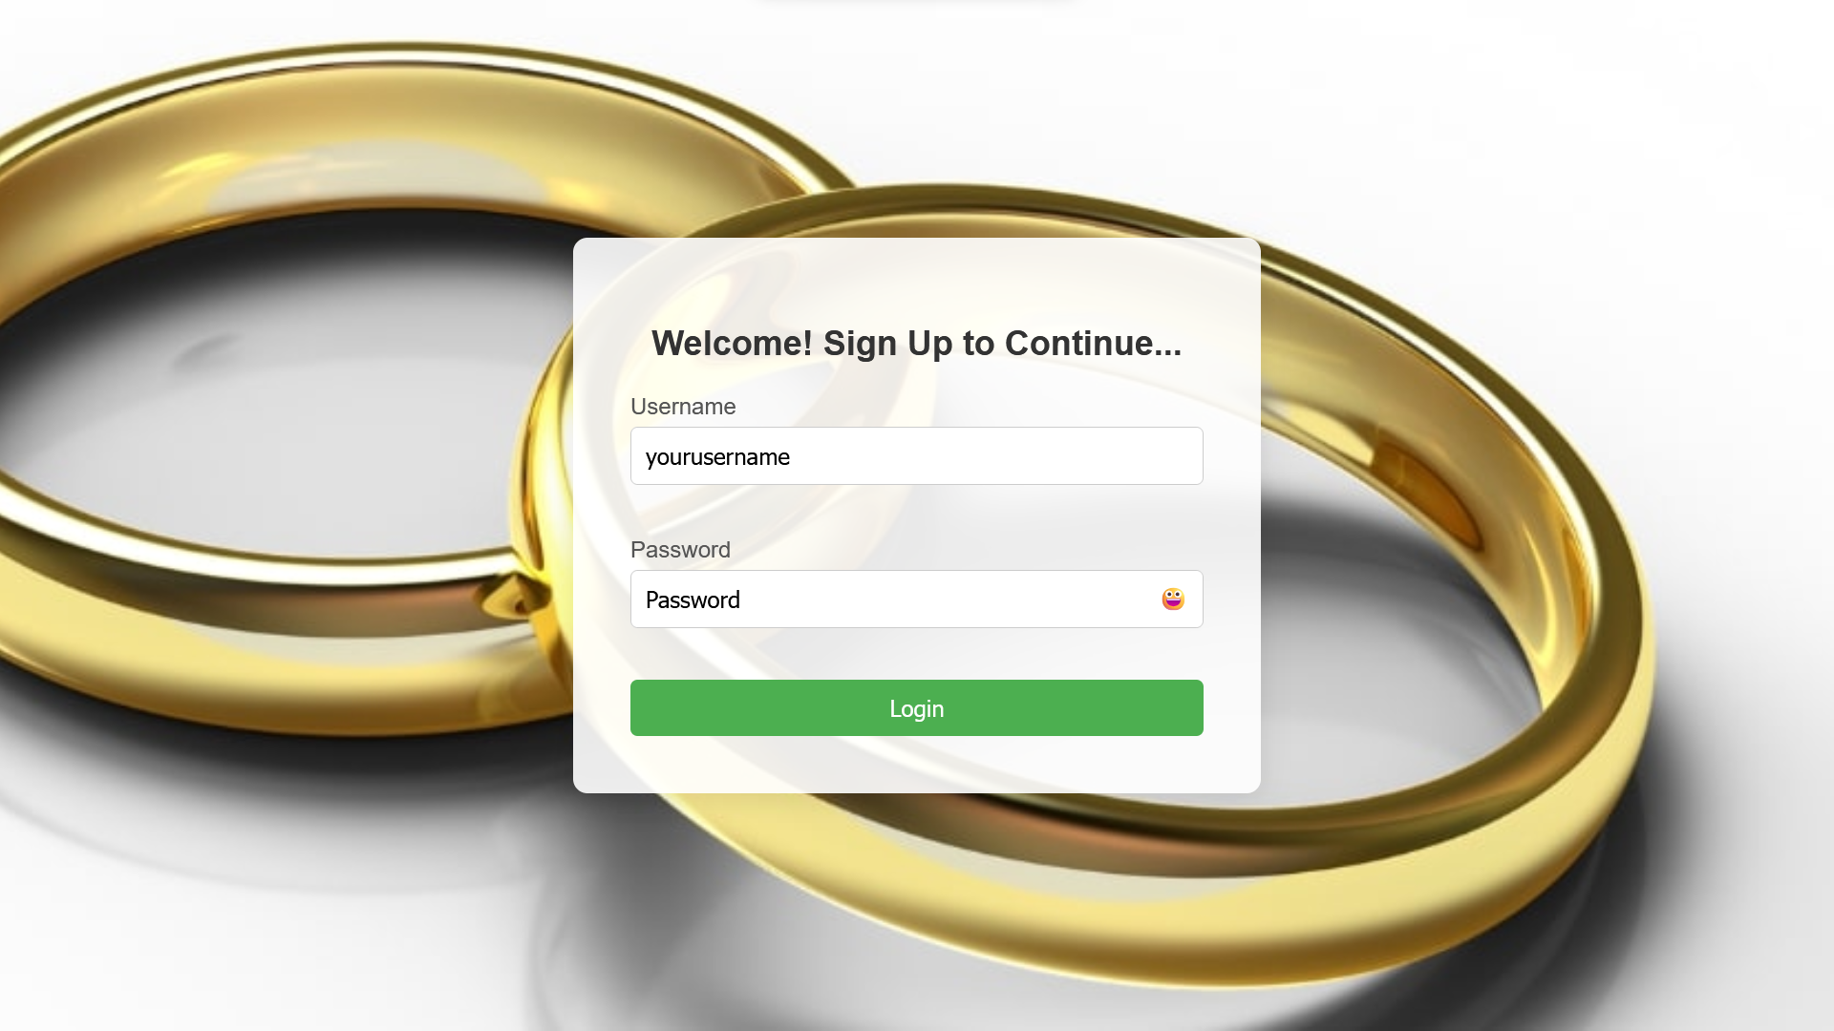

**Menu Overview**

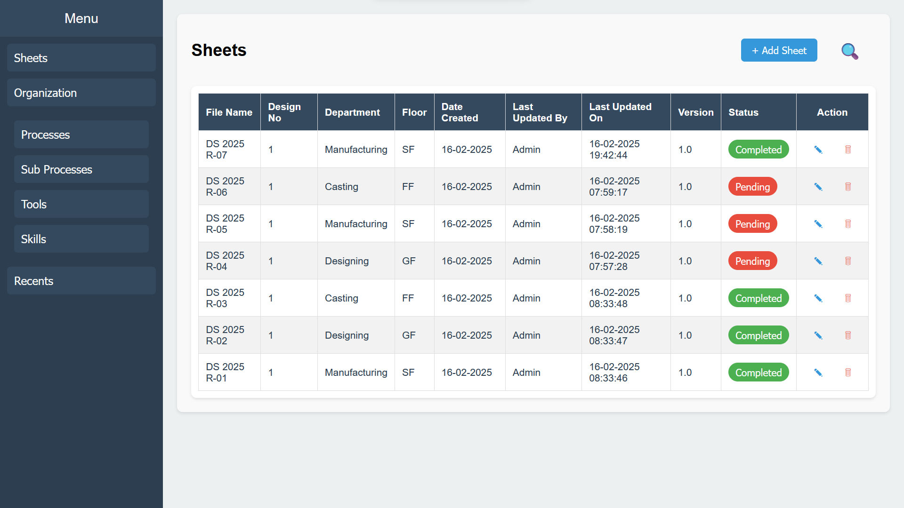

**Sheets Tab**

* **Purpose:** Displays all existing process sheets in the organization. Provides an option to add new sheets.

**Organization Tab**

* **Purpose:** Stores data essential for sheet preparation, including Processes, Sub-Processes, Tools, and Skills.

**Recents Tab**

* **Purpose:** Lists all recently modified sheets for quick and easy access.

**Sheets Tab Features**

**"+ New Sheet" Button**

* **Action:** Fill in all required details and click "Save" to create a new sheet.

 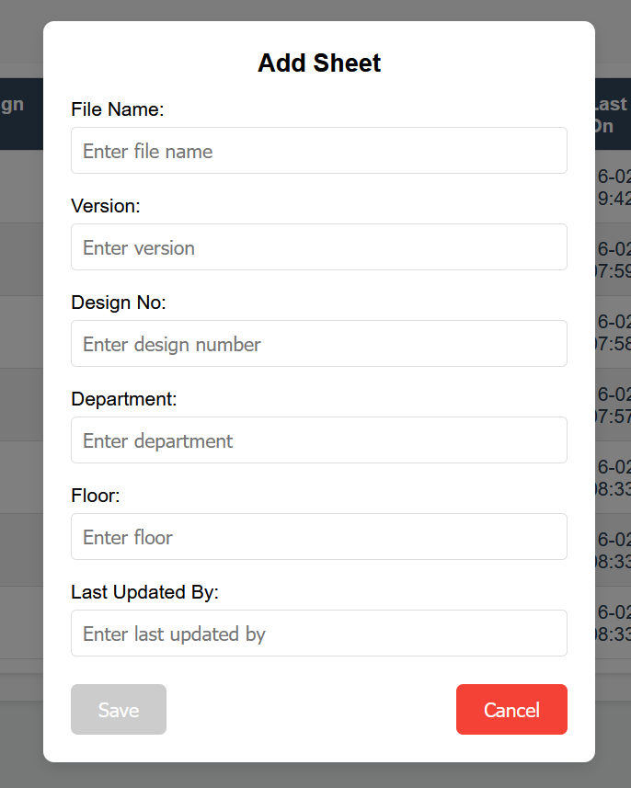

**"🔍" Button (Search)**

* **Default:** Displays sheets from the 1st of the current month to the current date.
* **Modify Range:** Change the date range to view specific records.
* **Search Button:** Use to filter sheets based on the selected criteria.
* **Clear:** Removes all filters and displays all sheets.

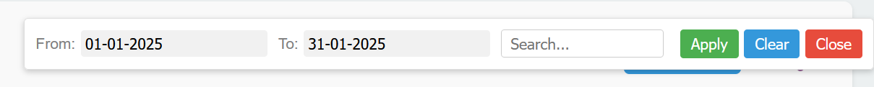

**Accessing and Managing Sheets**

* **View Sheet Data:** Click on the desired sheet row.
* **Edit:** Click the ✎ button (note: file names cannot be changed).
* **Delete:** Click the 🗑 button to remove a sheet.

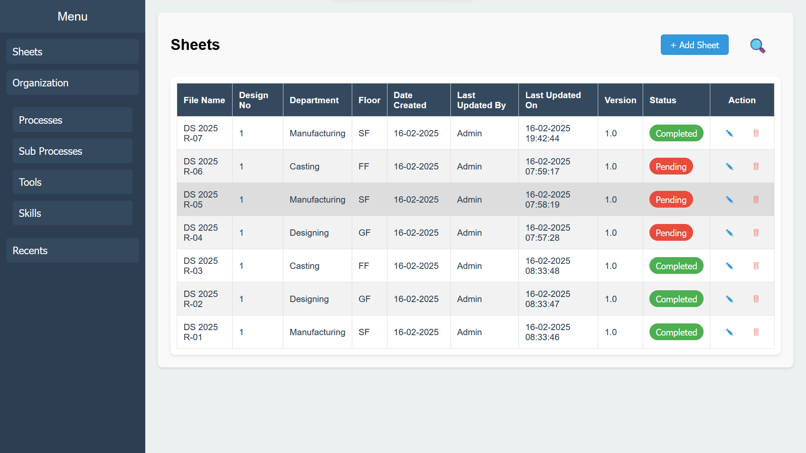

**Single Sheet Management**

* **Preview:** Click 👁 to preview the sheet.
* **Download:** Click 🗎 to download the sheet in Excel format.
* **Delete:** Click 🗑 to remove the current sheet.

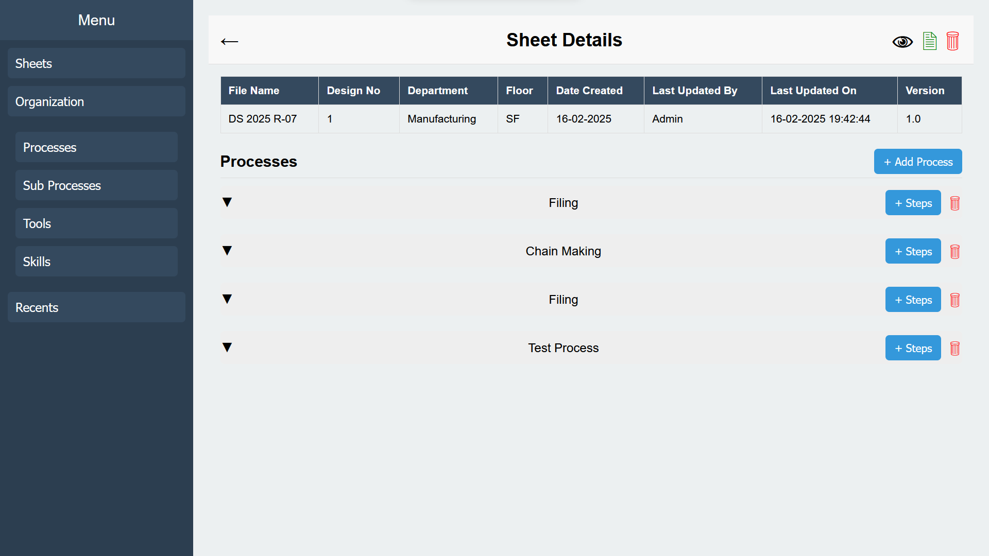

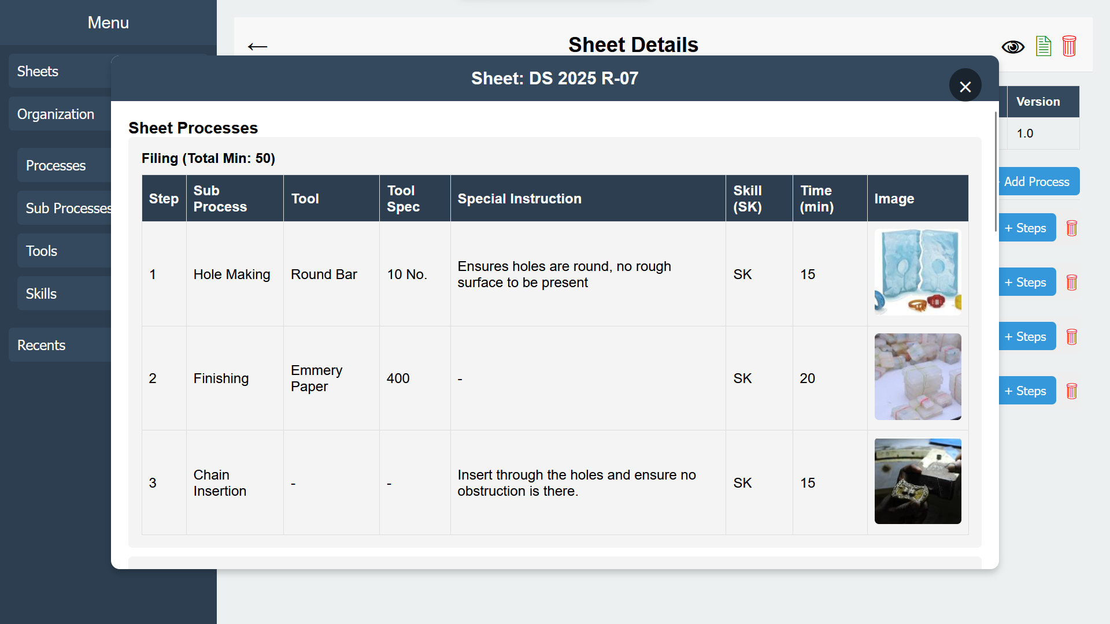

**Adding Processes and Steps**

* **Add Process:** Click **"+ Add Process**" and select a process. Click "Save."

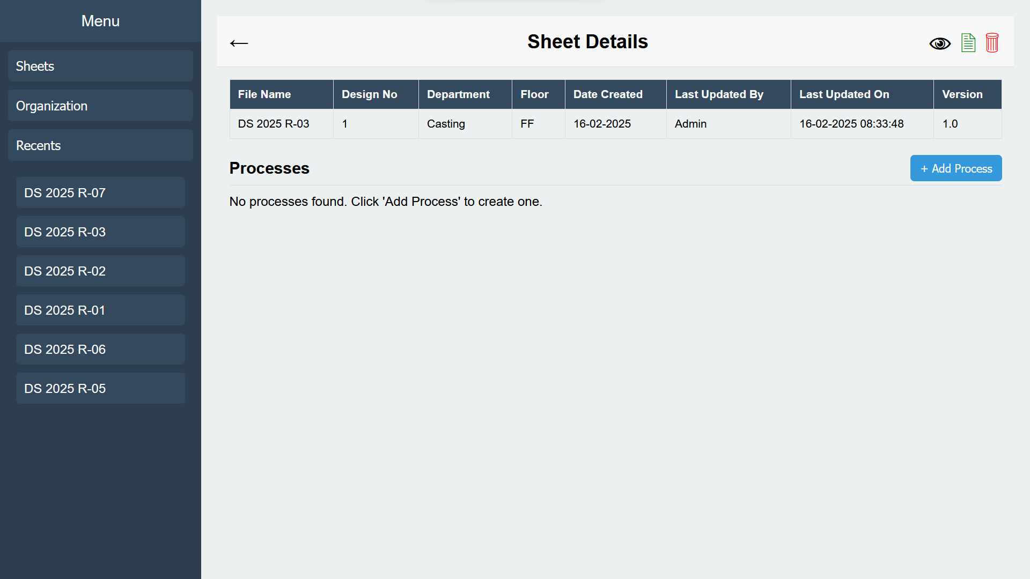 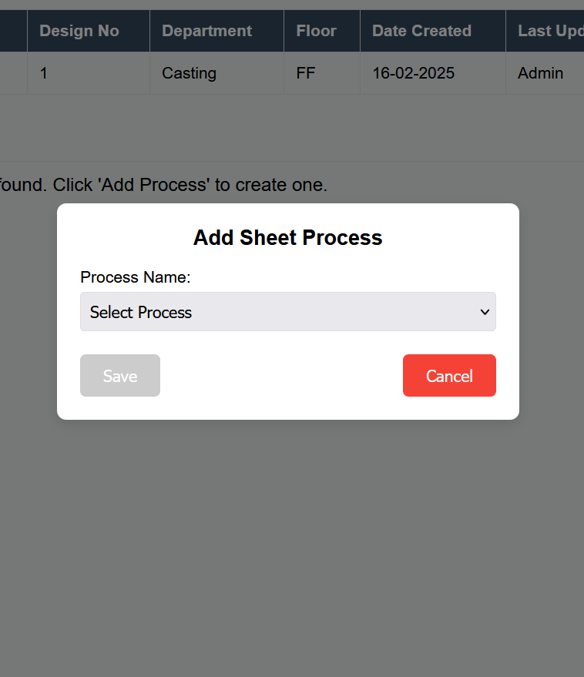

* **Add Steps:** Once a process is added, a new **"+ Steps**" button will appear.
  + Fill in the details and upload images (allowed formats: .jpg, .png, .jpeg).
  + To rearrange steps, modify the step numbers, and they will adjust automatically.
* **Delete Process:** Click the 🗑 button under a process to remove it.

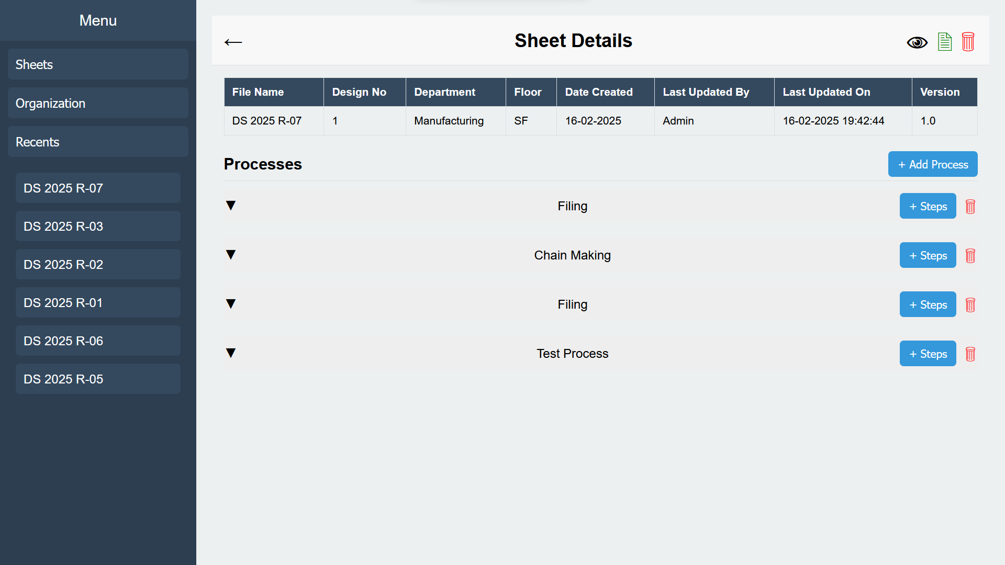

**Managing Steps**

* **View Steps:** Click on the desired process row.
* **Preview:** Click 👁 to preview a step.
* **Edit:** Click ✎ to modify a step.
* **Delete:** Click 🗑 to remove a step.

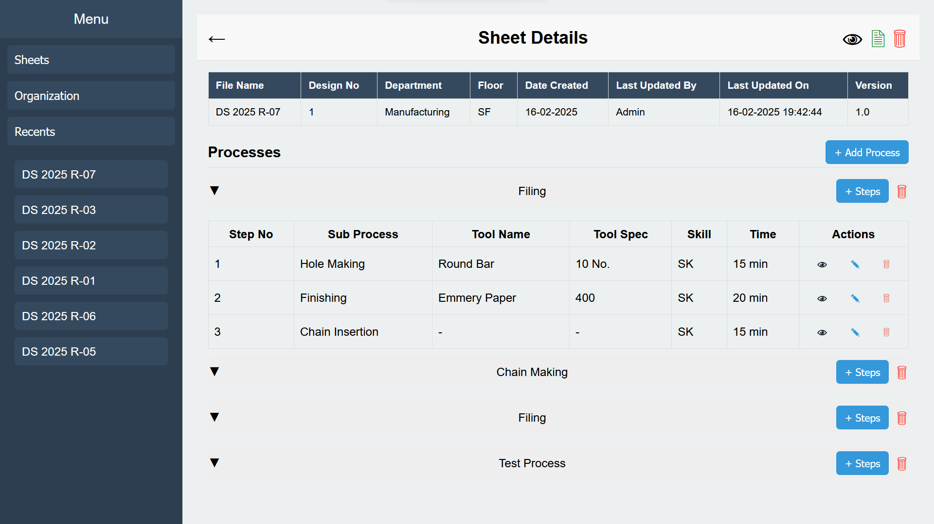 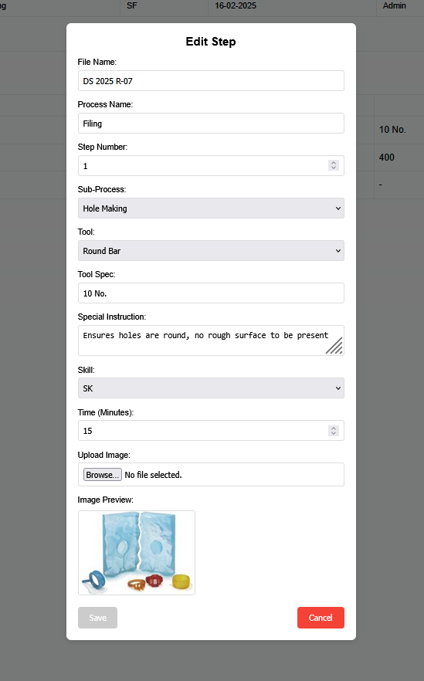

**Organization Tab Features**

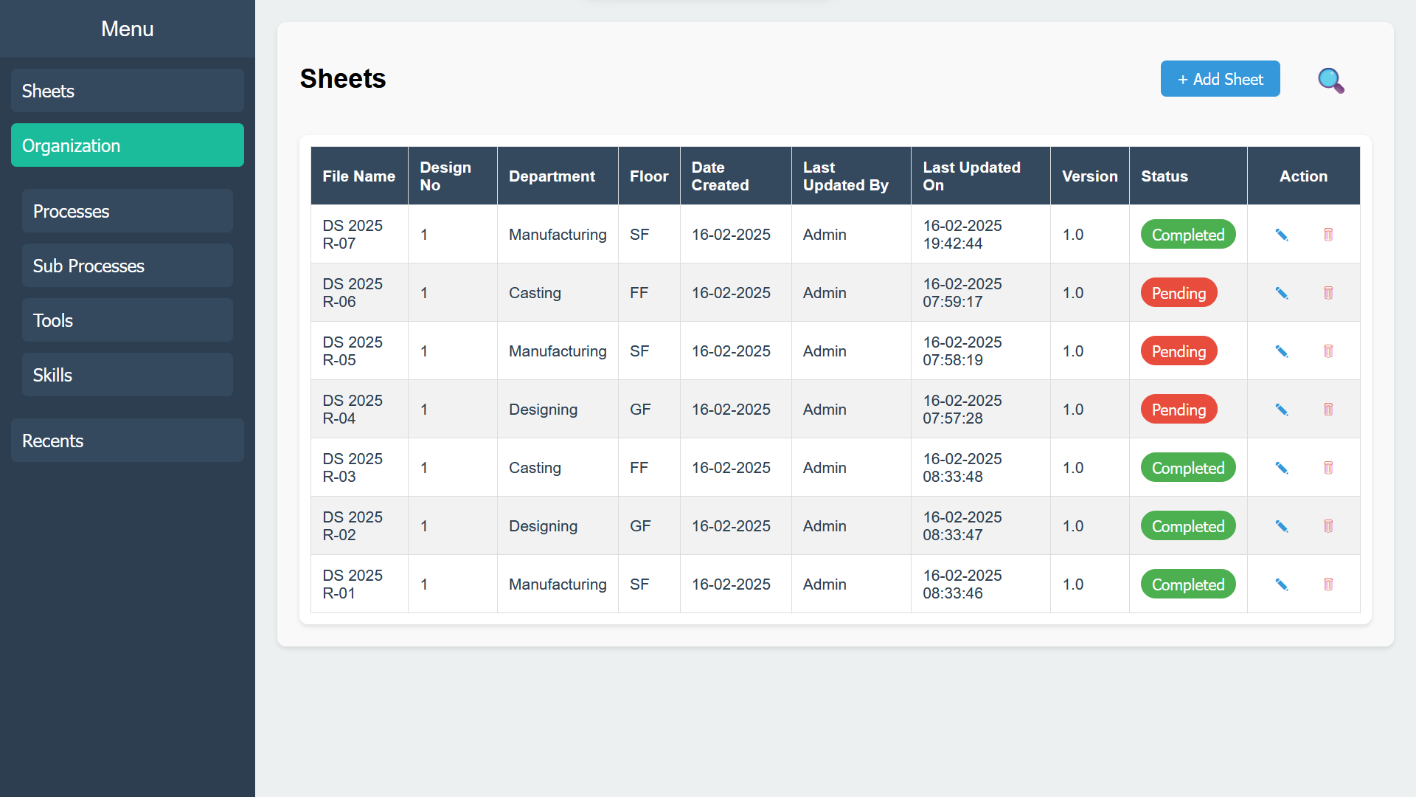

**Process Tab**

* **View Processes:** Displays all added processes.
* **Add Process:** Click "**+ Add Process**", fill in all fields, and click "Save."
* **Deactivate Process:** Edit the process and uncheck the "Active" box to hide it during sheet/sub-process creation.

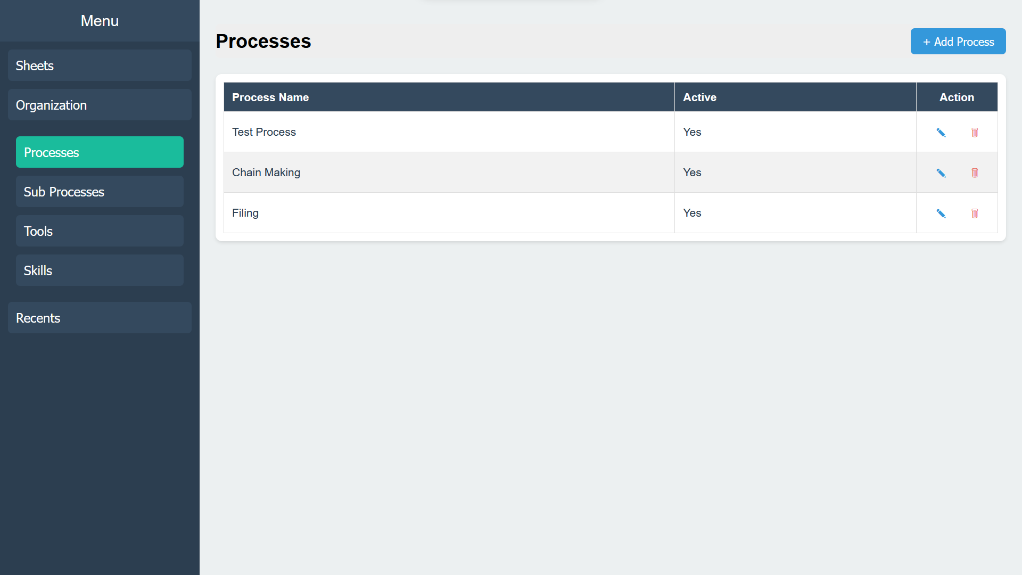 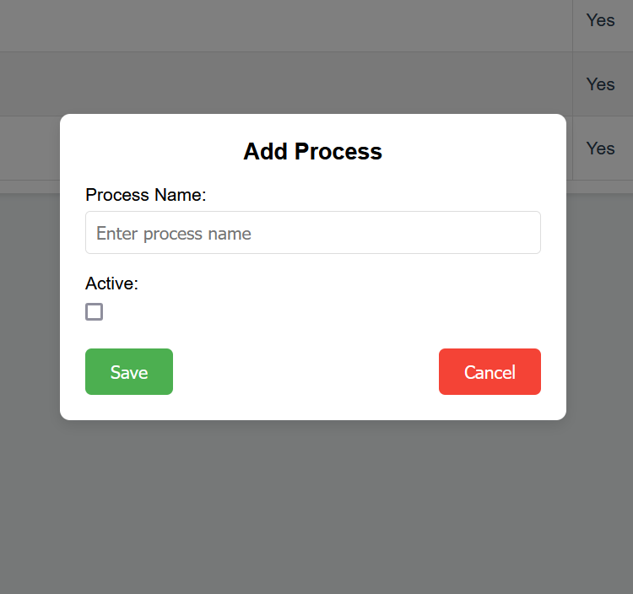

**Sub-Process Tab**

* **View Sub-Processes:** Displays all added sub-processes.
* **Add Sub-Process:** Click "**+ Add Sub-Process**". Ensure the related process is already added, select it from the dropdown, fill in details, and click "Save."
* **Deactivate Sub-Process:** Edit the sub-process and uncheck the "Active" box to hide it.

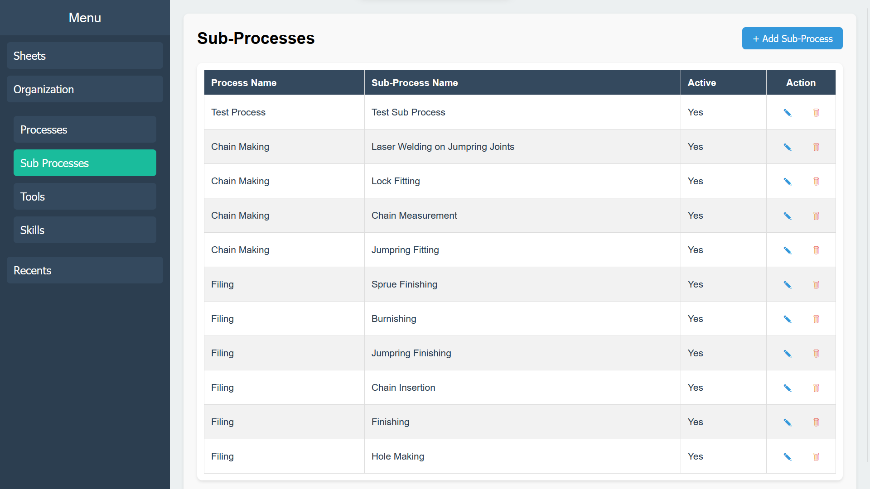 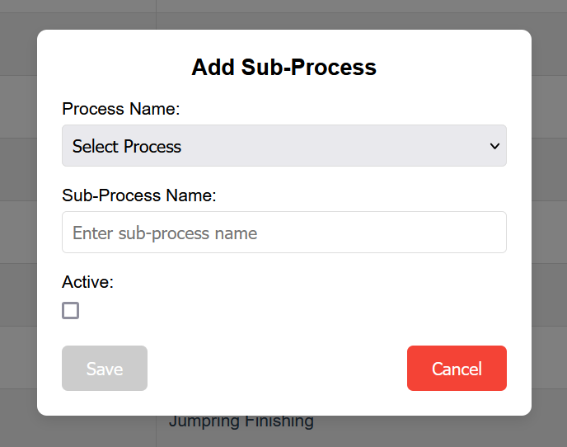

**Tools Tab**

* **View Tools:** Displays all added tools.
* **Add Tool:** Click "**+ Add Tools**". Ensure the related sub-process is already added, fill in all fields, and click "Save."
* **Deactivate Tool:** Edit the tool and uncheck the "Active" box to hide it.

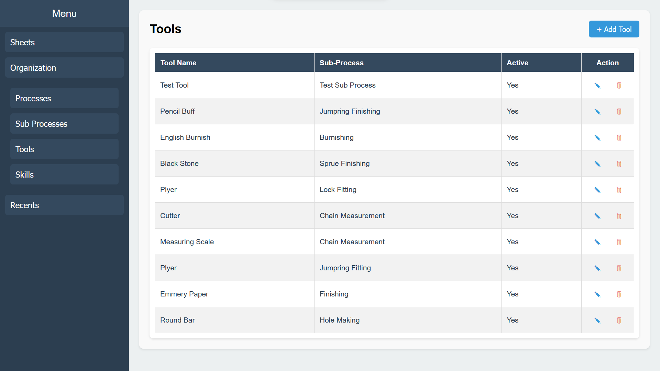 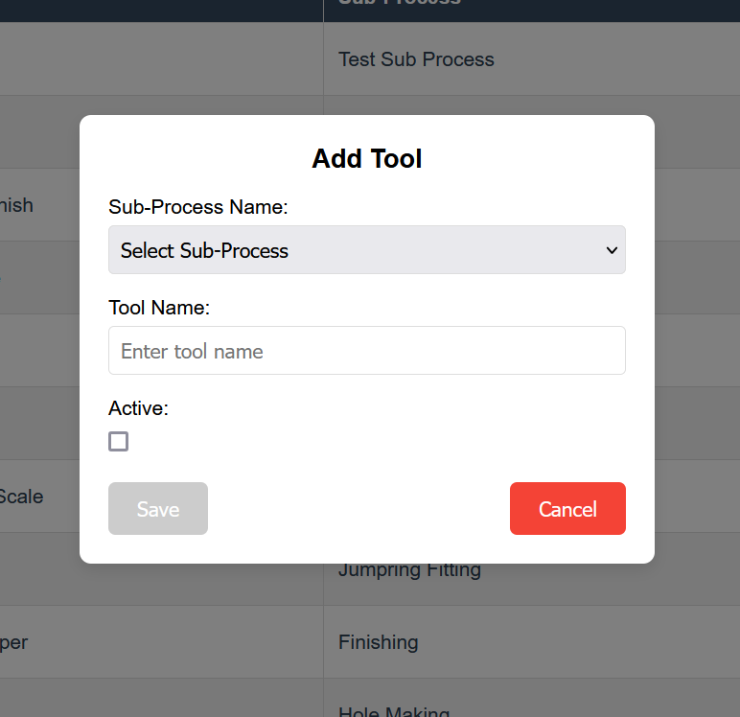

**Skills Tab**

* **View Skills:** Displays all required skills.
* **Add Skill:** Click "**+ Add Skills**", fill in all fields, and click "Save."
* **Deactivate Skill:** Edit the skill and uncheck the "Active" box to hide it during step creation.

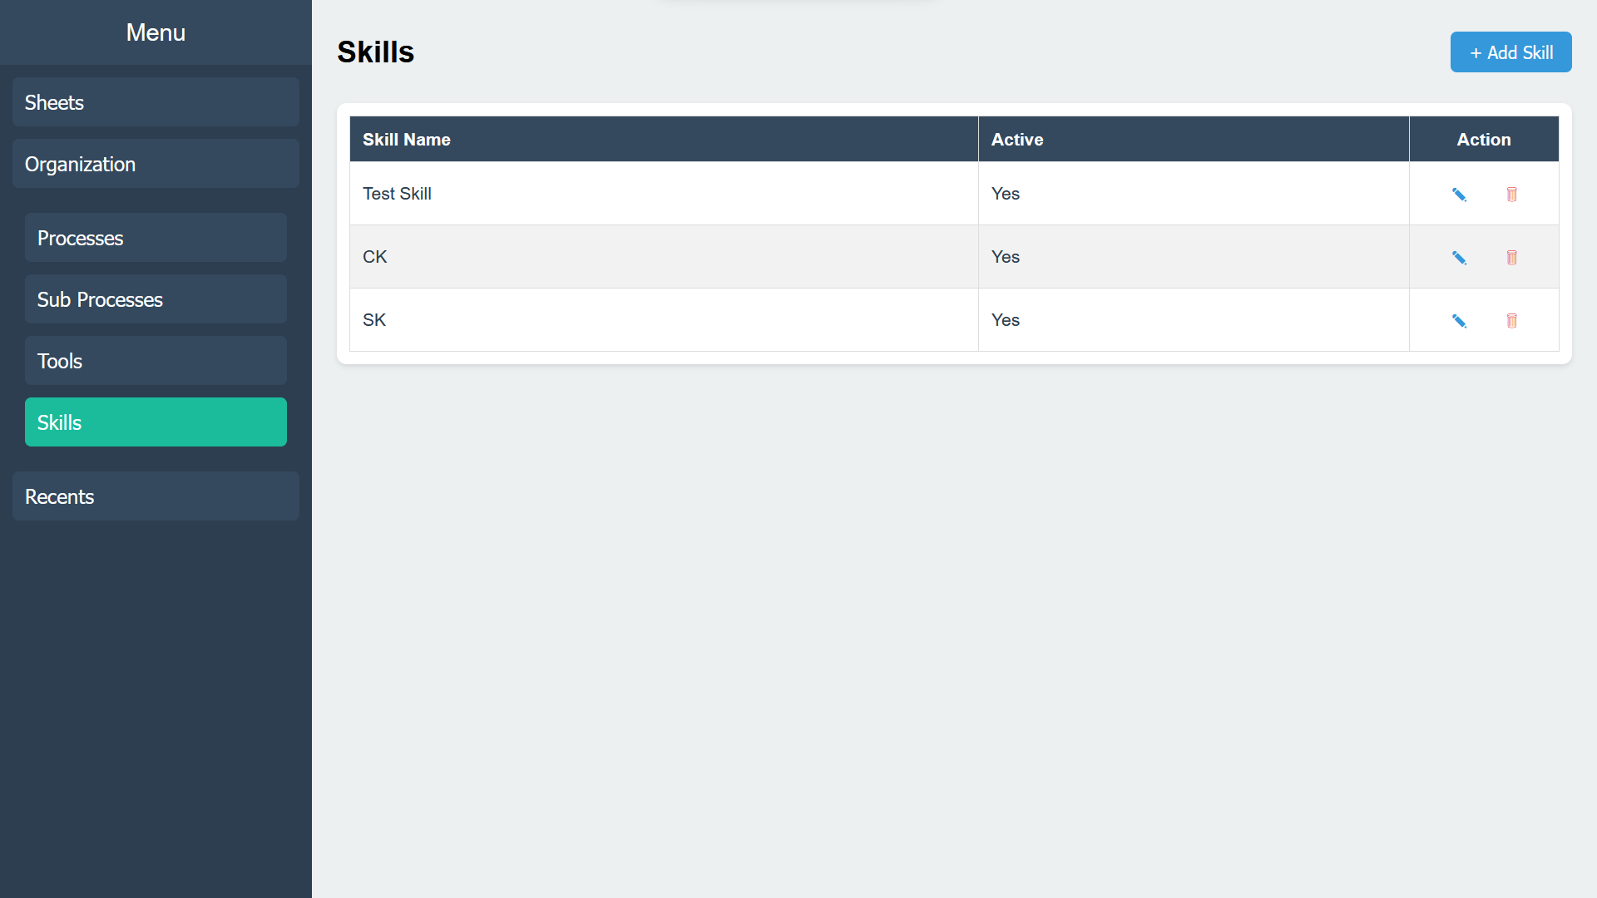 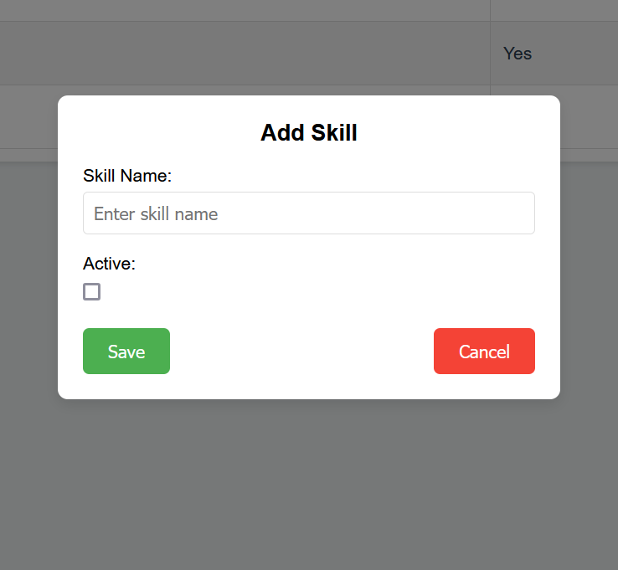

**Note:**

* Deleting a sub-process will also delete its associated tools.
* Deleting a process will also delete its associated sub-processes and tools.

**Recents Tab**

* **Purpose:** Displays all recently modified sheets for easy access and review.